Assessment Schedule – 2014
Mathematics and Statistics: Apply probability methods in solving problems (91267)
Evidence Statement
One | Expected Coverage | Achievement(u) | Merit(r) | Excellence(t)
(a)(i) | Proportion is 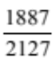 | Correct proportion. Accept equivalent.
(ii) | Proportion is 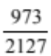 | Correct proportion. Accept equivalent.
(b) | Percentage is 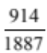× 100 = 48.4% |  | Correct percentage.
(c) | P(≥ 1 fracture using supplement A) = 0.086385  P(≥ 1 fracture using placebo) = 0.1393597  Relative risk of fracture taking supplement A relative to taking placebo is  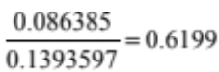  Justified response:  eg. Claim is incorrect, as closer to 0.6 than 0.5.  Accept also claim is correct as close to 0.5. | Calculates an individual risk. | Finds both individual risks  and the relative risk but does not address the claim. | Finds relative risk and states whether claim is correct or incorrect with justification.
(d) | If 100 people were treated, then 13.9% or 14 people got a fracture when using the placebo, and 8.6% or approximately 9 people got a fracture with supplement A, so 5 fewer people. Yes 5 in 100 is one in twenty so claim can be justified.  Alternatively, difference between risks of a fracture = 13.9 – 8.6 = 5.3 %, and so 5 fewer people. If 100 people were treated, then 5.3% or 5 people benefited. If 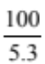 = 18.86 or 19 people were treated, then one person benefited. Hence just over one in twenty, so the claim is justified. |  | Calculations are made (0.053 and 1/20) but does not say whether the claim is justified. | Justifies claim with calculations.

NØ | N1 | N2 | A3 | A4 | M5 | M6 | E7 | E8
No response; no relevant evidence. | A valid attempt at one question | 1 of u | 2 of u | 3 of u | 1 of r | 2 of r | 1 of t, with minor errors ignored | 2 of t

Two | Expected Coverage |  | Achievement(u) | Merit(r) | Excellence(t)
(a)(i) |  | P(X > 1000) = P(Z > 0.4) = 0.5 – 0.15542 = 0.3446 | Probability found.
(ii) |  | 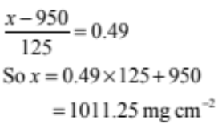 |  | Finds bone density value.
(iii) |  | P(0 < z < 0.49) = 0.1879. So proportion of 25-year-old females aged 25 having BMD less than Jane’s is 0.6879. | Finds proportion.
(b) |  | P(X > 1000) = 0.656, so P(X < 1000) = 0.344  z = – 0.4016  so mean  =1000 + 0.4016 × 150  =1060.24 mg cm^{–2} |  | z found. | Mean found with correct working.
(c)(i) |  | 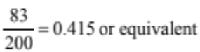 | Finds proportion.
(ii) |  | There are 53 / 200 above the modal group of 0 to 0.3 in ability, and also 53 / 200 above the modal group of student marks. However, there are only four of the most able students (above 0.9 in ability), which are probably included in the top scores of 56 to 59. But as this latter group has in fact 11 students – it does not discriminate between them. |  | Reference to statistical data and top ability group.
(iii) |  | Comments should include reference to the shape of the graph, the centre of the distribution and the spread of data.  Some possible comments are given below.  - Student test marks are bunched together with most between 47 and 55. The modal interval is 50 to 52, and has 64 or about one third of the students in it.  - The student marks are skewed towards the lower values. The lowest are between 32 and 34, and the highest are between 56 and 58.  - 117 test marks are 50 or higher. Because of this and the skew to the left, this affects the mean, which is slightly less than 50. The range is just under 6 times the standard deviation.  - The ability scores seem to be bunched together as well, with most values between –0.6 and 0.6. More than two thirds of the values lie here.  - However the shape is approximately normal, as the shape is almost symmetrical and roughly bell-shaped with a mean just below zero (given). The modal interval is 0 to 0.3, and the median is also in this interval. Because the data is approximately normally distributed, it is likely that the mean, median, and mode are very similar, which is also a feature of a normal distribution.  - Over two thirds of the data seems to be between the scores of –0.6 and 0.6 (actual number is 158 / 200 or 79%), so it makes sense for the standard deviation to be around 0.5. Actual value is 0.465. | Two statements covering two different aspects of shape, centre and spread. | As for achieved, but must include a comparative statement.  Need to have numeric quantific-ation for the statements. | As for merit, but must have all three aspects and two comparative statements.

NØ | N1 | N2 | A3 | A4 | M5 | M6 | E7 | E8
No response; no relevant evidence. | A valid attempt at one question. | 1 of u | 2 of u | 3 of u | 1 of r | 2 of r | 1 of t, with minor errors ignored | 2 of t

Three | Expected Coverage | Achievement(u) | Merit(r) | Excellence(t)
(a) | P(loses) = 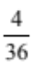 or equivalent. | Probability found.
(b) | P(neither win nor lose)  = P(1 – prob of 2,3,12,7 or 11 occurring)  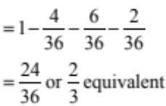 | Finds the probability of winning or losing. | Finds probability.
(c)(i) | P(5) = | Probability found.
(ii) | Probability (win on third roll when 5 on first)  = P(not 5 or 7 on second roll) × P(5 on third roll)  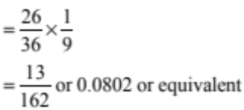 |  | Probability of neither winning nor losing on the second roll found. | Correct probability with working shown.
(d) | To be fair, we need P(win) = P(lose) = 0.5  Let the probability that Matiu wins after getting a sum other than 2,3,7,11 or 12 be x.  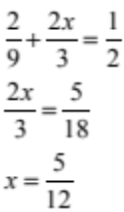 | Recognition that fairness gives  p = 0.5 | Correctly sets up an equation. | Sets up the problem, and finds x = 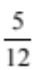

NØ | N1 | N2 | A3 | A4 | M5 | M6 | E7 | E8
No response; no relevant evidence. | A valid attempt at one question. | 1 of u | 2 of u | 3 of u | 1 of r | 2 of r | 1 of t, with minor errors ignored | 2 of t

Cut Scores
 | Not Achieved | Achievement | Achievement with Merit | Achievement with Excellence
Score range | 0 – 8 | 9 – 13 | 14 – 18 | 19 – 24

